Risky Cities: Flow of Words
Artist Commission
Application Form
September-October 2022

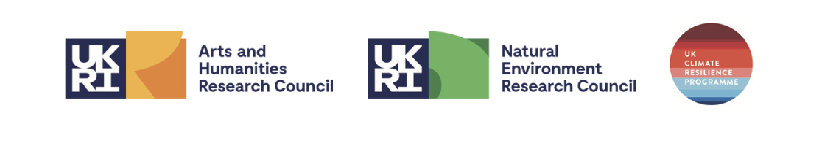
ABOUT THIS APPLICATION FORM

Before completing this application form, please refer to the Risky Cities: Flow of Words Information Pack available here and email your expression of interest to jack.chamberlain@hull.ac.uk to receive access to the Flow of Words Community Pack.

Part 1: WHO IS ELIGIBLE?

We are looking to commission artists who work within any artistic discipline and have an ‘HU’ postcode.

The artistic response must have a live performance element and/or would be able to be exhibited live in some way at a sharing. For example, an illustrator might be able to present their work/s and talk about the inspiration and process or a costume designer might choose to exhibit and speak about a costume that they have designed.

Part 2: HOW TO APPLY

Application deadline: All applications must be received at or before noon on Friday 7th October.

You can apply in any form that suits you best, including written responses, audio recordings or video responses.

To apply in writing, please complete this application form and email it to jack.chamberlain@hull.ac.uk.

To apply via audio or video, please ensure that you answer all the questions that feature in this application form and send your content via WeTransfer or a similar file transfer system to jack.chamberlain@hull.ac.uk.

This application has been designed to ensure that applicants are not expected to have to undertake a lengthy application process to be eligible for consideration. Please do not feel that you need to undertake extensive research or preparation in order to complete your application: the most important thing is to give us a clear sense of the work that you might produce if you were commissioned for the project, so that we can assess your application at the shortlisting stage.

Part 3: ARTIST/ORGANISATION DETAILS

Company / artist name
Name of lead contact
Website or blog (if applicable)
Postal address
Contact email address
Contact telephone number

Part 4: APPLICATION QUESTIONS

Please respond to the questions in the format that suits you best. Where applicable, word count or video/audio lengths have been specified next to the question.

Q1: How would you describe your primary artistic practice? E.g. painter, theatre maker, poet.

Q2: Please outline any examples that you have of relevant previous work and provide links to documentation if possible.

Q3: Please tell us about your idea, how it will be presented and how the community pieces have inspired you. 400 words or 2 minutes 30 seconds audio or video

Q4: What does water in Hull mean to you? 200 words or 1 min 30 seconds audio or video

Q5: Using the table below, please give us an idea of how you will spend the £1750 commission fee

For example, you might like to tell us about yours or other artists fees, any equipment you will need to purchase or any travel costs. Due to the nature of this commission, we would expect that you would use the majority of the budget on artist fees. The University is able to provide work/rehearsal space where appropriate so we would only expect to see costs for room hire in exceptional circumstances or to cover bills cost for owned/rented spaces. The University will also cover any reasonable music licensing costs.

Please add more lines to the table if necessary.

Expenditure Item | Description | Amount

Q6: Please confirm that you are available for all of the essential dates listed below and please list any non-essential dates that you are unavailable for

EVENT | DATE | LOCATION
Round table meeting between commissioned artists, community participants and Risky Cities team | Thursday 20th October 2022 | The University of Hull Campus
Work in progress sharing with participants and Risky Cities team (essential) | Friday 28th October 2022 | The University of Hull Campus
Dress and Technical rehearsal (essential) | Weds 9th November 2022 | Gulbenkian Centre, The University of Hull Campus
Sharing 1 (essential) | Thurs 10th November 2022 | Gulbenkian Centre, The University of Hull Campus
Sharing 2 (essential) | Friday 11th November 2022 | The Freedom Centre, Preston Road
Half day evaluation session | Thursday 17th November 2022 | The University of Hull Campus

Please submit your application to jack.chamberlain@hull.ac.uk on or before Friday 7th October 2022.

We look forward to reading your application,
The Risky Cities Team

